**SUGANTHI G**

**727721EUIT163**

**CA – 1**

**QUESTION – 1:**

**package** com.exam.exam;

**import** org.openqa.selenium.By;

**import** org.openqa.selenium.WebDriver;

**import** org.openqa.selenium.WebElement;

**import** org.openqa.selenium.chrome.ChromeDriver;

**import** org.openqa.selenium.chrome.ChromeOptions;

**import** io.github.bonigarcia.wdm.WebDriverManager;

**public** **class** Exe1 {

**public** **static** **void** main(String[] args) **throws** InterruptedException {

ChromeOptions co=**new** ChromeOptions();

co.addArguments("--remote-allow-origins=*");

WebDriverManager.chromedriver().setup();

WebDriver driver=**new** ChromeDriver(co);

driver.get("https://www.amazon.in/");

driver.manage().window().maximize();

System.out.println(driver.getTitle());

String atitle=driver.getTitle();

String etitle="Online Shopping site in India: Shop Online for Mobiles, Books, Watches, Shoes and More - Amazon.in";

**if**(etitle.equals(atitle)) {

System.out.println("Title Matched!!!");

}

driver.get("https://www.amazon.in/Mysore-Sandal-Soap-150g-Pack/dp/B00BMR071W/ref=sr_1_8?keywords=soap&qid=1681290552&sr=8-8");

driver.manage().window().maximize();

driver.findElement(By.xpath("//*[@id=\"add-to-cart-button\"]")).click();

WebElement t=driver.findElement(By.xpath("//*[@id=\"NATC_SMART_WAGON_CONF_MSG_SUCCESS\"]/span"));

String current=t.getText();

String expected="Added to Cart";

**if**(current.equals(expected)) {

System.out.println("CART VERIFIED");

}**else** {

System.out.println("CART NOT VERIFIED");

}

driver.findElement(By.xpath("/html/body/div[1]/header/div/div[7]/div[1]/div/div/div[4]/div/div/div[2]/div[3]/div[7]/div[1]/span/span/span[1]/span/span/span/span/span")).click();

WebElement s=driver.findElement(By.xpath("//*[@id=\"nav-cart-count\"]"));

String upd1=s.getText();

String upd="Amazon Cart is Updated ";

**if**(upd1.equals(upd)) {

System.out.println("NOT UPDATED");

}**else** {

System.out.println("UPDATED");

}

driver.findElement(By.xpath("/html/body/div[1]/header/div/div[7]/div[1]/div/div/div[4]/div/div/div[2]/div[3]/div[7]/div[2]/div/span/span/span/input")).click();

WebElement r=driver.findElement(By.xpath("//*[@id=\"nav-cart-count\"]"));

String old1=r.getText();

String old="Your Amazon Cart is empty";

**if**(old1.equals(old)) {

System.out.println("NOT REMOVED");

}**else** {

System.out.println("REMOVED");

}

}

}

**OUTPUT:**

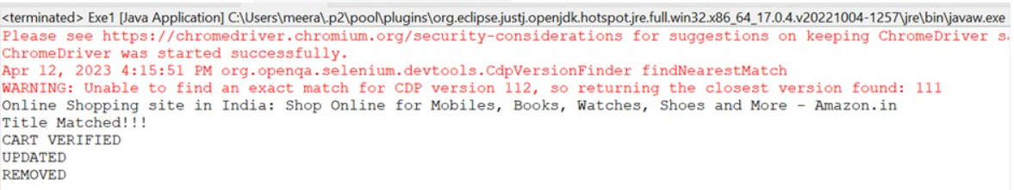

**QUESTION – 2:**

**package** com.exam.exam;

**import** java.util.List;

**import** org.openqa.selenium.By;

**import** org.openqa.selenium.WebDriver;

**import** org.openqa.selenium.WebElement;

**import** org.openqa.selenium.chrome.ChromeDriver;

**import** org.openqa.selenium.chrome.ChromeOptions;

**import** io.github.bonigarcia.wdm.WebDriverManager;

**public** **class** q2 {

**public** **static** **void** main(String[]args) **throws** InterruptedException {

ChromeOptions co=**new** ChromeOptions();

co.addArguments("--remote-allow-origins=*");

WebDriverManager.chromedriver().setup();

WebDriver d=**new** ChromeDriver(co);

d.get("https://www.amazon.in/?&ext_vrnc=hi&tag=googhydrabk1-21&ref=pd_sl_7hz2t19t5c_e&adgrpid=58355126069&hvpone=&hvptwo=&hvadid=486458712209&hvpos=&hvnetw=g&hvrand=2969571477685556505&hvqmt=e&hvdev=c&hvdvcmdl=&hvlocint=&hvlocphy=9300009&hvtargid=kwd-10573980&hydadcr=14453_2154373");

d.manage().window().maximize();

String currenttitle="Online Shopping site in India: Shop Online for Mobiles, Books, Watches, Shoes and More - Amazon.in";

String expectedtitle=d.getTitle();

**if**(currenttitle.equals(expectedtitle)) {

System.out.println("Title is verified");

}

**else** {

System.out.println("Title is Not Verified");

}

d.findElement(By.xpath("//*[@id=\"twotabsearchtextbox\"]")).sendKeys("watches");

d.findElement(By.xpath("//*[@id=\"nav-search-submit-button\"]")).click();

String str1=d.findElement(By.xpath("//*[@id=\"search\"]/span/div/h1/div/div[1]/div/div")).getText();

String str2="1-48 of over 90,000 results for \"watches\"";

**if**(str1.equals(str2)) {

System.out.println("Searched product list is Displayed");

}

**else** {

System.out.println("Searched product list is displayed");

}

Thread.sleep(3000);

List<WebElement>li=d.findElements(By.xpath("//span[@class=\"a-size-base-plus a-color-base a-text-normal\"]"));

**int** c=0;

**for**(WebElement link:li) {

System.out.println(link.getText());

c++;

**if**(c>5) {

**break**;

}

}

d.findElement(By.xpath("//*[@id=\"n/2563504031\"]/span/a/span")).click();

String str3=d.findElement(By.xpath("//*[@id=\"search\"]/span/div/h1/div/div[1]/div/div")).getText();

String str4="1-48 of over 30,000 results for \"watches\"";

**if**(str3.equals(str4)) {

System.out.println("Searched product list is Displayed according to applied filter");

}

**else** {

System.out.println("Searched product list is not Displayed according to applied filter");

}

}

}

**OUTPUT:**

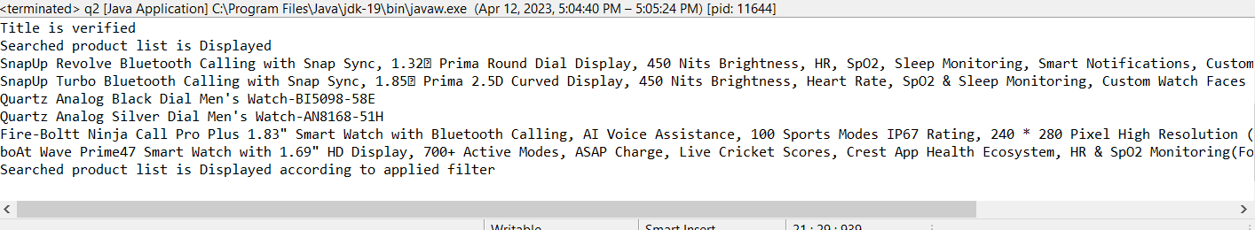

**QUESTION – 3:**

**package** com.exam.exam;

**import** org.openqa.selenium.By;

**import** org.openqa.selenium.WebDriver;

**import** org.openqa.selenium.chrome.ChromeDriver;

**import** org.openqa.selenium.chrome.ChromeOptions;

**import** io.github.bonigarcia.wdm.WebDriverManager;

**public** **class** q3 {

**public** **static** **void** main(String[]args) **throws** InterruptedException {

ChromeOptions co=**new** ChromeOptions();

co.addArguments("--remote-allow-origins=*");

WebDriverManager.chromedriver().setup();

WebDriver d=**new** ChromeDriver(co);

d.get("https://www.amazon.in/gp/css/homepage.html?ref_=nav_AccountFlyout_ya");

d.manage().window().maximize();

String currenttitle="Your Account";

String expectedtitle=d.getTitle();

**if**(currenttitle.equals(expectedtitle)) {

System.out.println("Title is verified");

}

**else** {

System.out.println("Title is Not Verified");

}

String et="Your Account";

String ct=d.findElement(By.xpath("//*[@id=\"a-page\"]/div[2]/div/div[1]/h1")).getText();

**if**(ct.equals(et)) {

System.out.println("Your account is Displayed");

}

**else** {

System.out.println("Your account is Not displayed");

}

d.get("https://www.amazon.in/gp/your-account/order-history?ref_=ya_d_c_yo");

d.findElement(By.xpath("//*[@id=\"ap_email\"]")).sendKeys("9342874722");

d.findElement(By.xpath("//*[@id=\"continue\"]")).click();

d.findElement(By.xpath("//*[@id=\"ap_password\"]")).sendKeys("notnow@1617");

d.findElement(By.xpath("//*[@id=\"signInSubmit\"]")).click();

String cor=d.findElement(By.xpath("//*[@id=\"a-page\"]/section/div[1]/div[2]/div[1]/h1")).getText();

String eor="Your Orders";

**if**(cor.equals(eor)) {

System.out.println("Your orders is Displayed");

}

**else** {

System.out.println("Your orders is Not displayed");

}

d.findElement(By.xpath("//*[@id=\"a-autoid-2-announce\"]")).click();

System.out.println("No recent items");

}

}

**OUTPUT:**

